Setting up Google Sheets for the Department

Please note: anyone using Google sheets must have a Google account. You can create one for free with whichever email you’d like. It is advised that employees do NOT use their personal Gmail accounts for company work. Instead, please create a Google account with the company provided email address for the employee. Part A shows how to create a Google account with a company provided email address.

Contents:
Part A: Creating a Google Account (first time employee)
This section shows how to create a Google account for a new employee using a company provided email address. This must be done before anything else for a new employee as an account is required to perform certain actions on a Google sheet.

Part B: Preparing Google sheets for first time use (first time only)
This section involves setting up Google sheet for the first time. Once a sheet is set up with permissions/settings, these steps do not have to be done again. Please skip if you already have a sheet set up for your daily excel file to upload. If you are sharing the sheet with a new employee to the sheet, please repeat part [B3] to give the employee permission to the sheet.

[B1]: Creating a new Google sheet
[B2]: Adjusting the sheet settings
[B3]: Sharing the sheet with others

Part C: Upload a new day’s sheet (daily)
This section is done daily whenever there is a new excel file to upload with information for the department to share.

[C1]: Preserving the current sheet (saving)
[C2]: Importing a new sheet (uploading)
Part A: Creating a Google Account
(first time employee)
- Go to Google.com
- If you are already logged in to an account (maybe your personal?), click the down arrow and click the sign out button. If you do not see this, then you can skip this step.
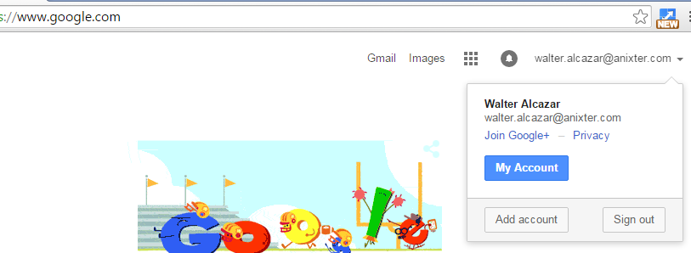

- Click the Sign in button
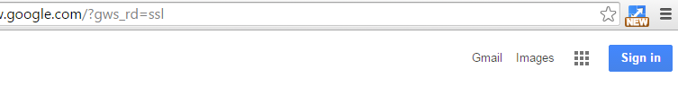
- Click “Sign in with a different account”, If you do not see this, you can skip to number 6.
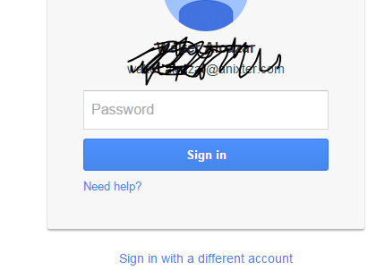

- Click “Remove”, and click the X on all accounts to remove them. Click “Done” once all accounts have been removed.
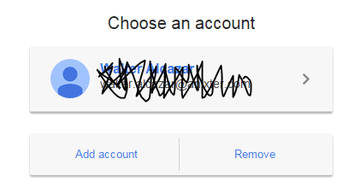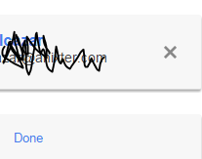
- Click Create Account.
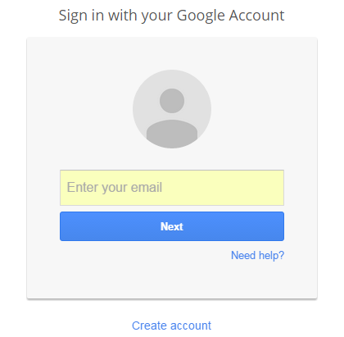

- Click the blue link that says “I prefer to use my current email address”
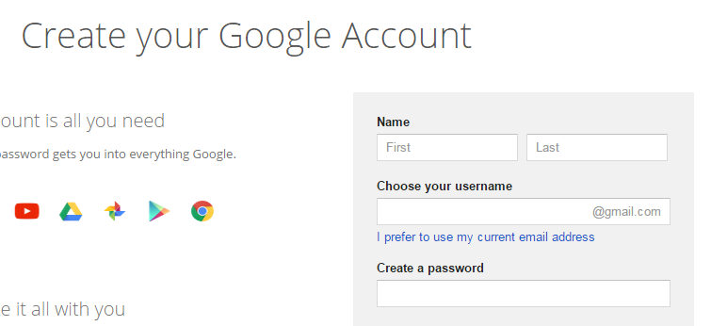

- Fill in all of the information listed. Important: Please change your Location to the proper country (US, UK, etc.)
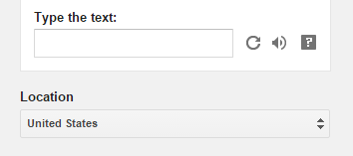

- If you see a window pop up asking you to agree to the privacy terms for Google, please scroll down the window so that you can click I Agree to continue.
- The browser should now show that an email was sent to verify your email address.
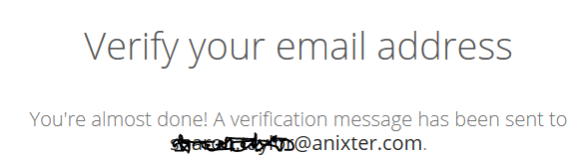

- Please go to your company email inbox to click the verification link.
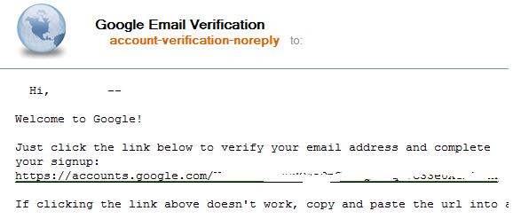

- A welcome webpage should show with your name on the web browser now.
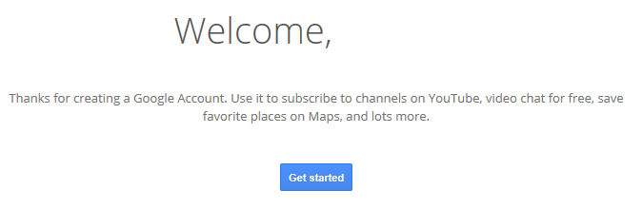

- Go to sheets.google.com
- Close the window that offers a tour of Google sheets:
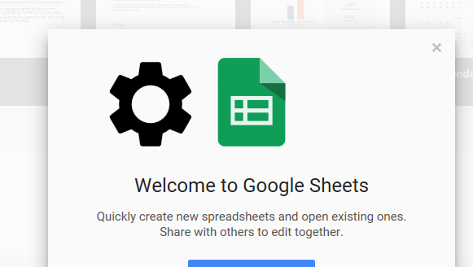

- Bookmark this page. This is your sheets homepage and you can access any sheets that you have access to or have created with this account.

Part A Complete
Part B: Preparing Google Sheets for First Time Use (first time only)
[B1]: Creating a new Google Sheet
- Go to Sheets.google.com
- If you are prompted to sign in, please sign in to continue.
- Click the “+” to start a new spreadsheet. If you already have a Google sheet page open, you can click File, New -> Spreadsheet instead. Either way works.
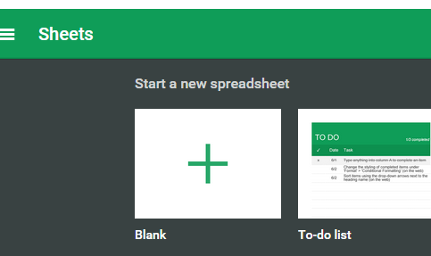 Or 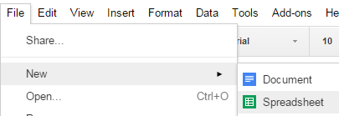

- Rename the sheet from “Untitled Spreadsheet” to the name “Cash Book” by clicking it and typing it in.

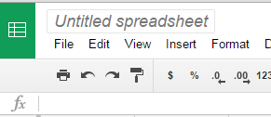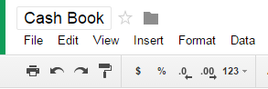

[B2]: Adjusting the sheet settings
- Click “File”. Click “Spreadsheet settings…”
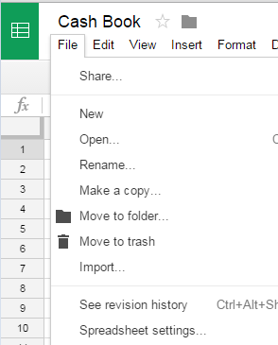

- Select the proper Locale, Time zone, and change Recalculation to “On change and every minute”
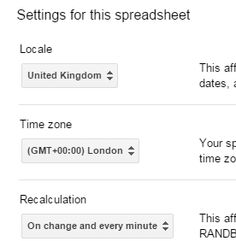
[B3]: Sharing the sheet with others
- Click the blue “Share” button
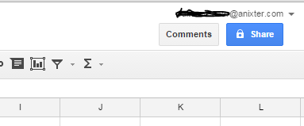

- Type in the full email address of the person you’d like to share this with.
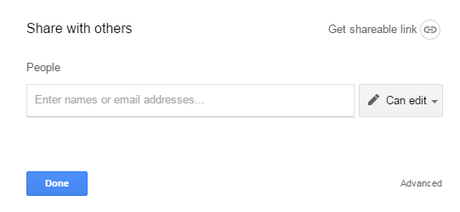
- Note: If the person does not have a Google account set up with their email address, it will warn you before sending the invitation. Please make sure you typed his/her email address correctly. If the employee does not have a gmail account set up for that address, Click “No” and please go through Part A to set up a Google account with that employee. If you don’t see this warning, skip this step.
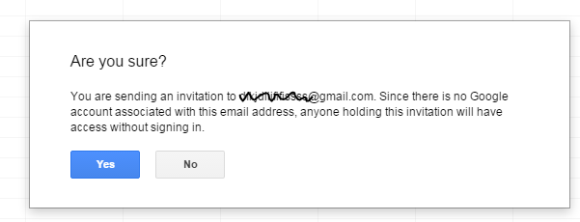
- Once you are done adding all the email addresses to the sheet, click “Send” to send the invites to the sheet.
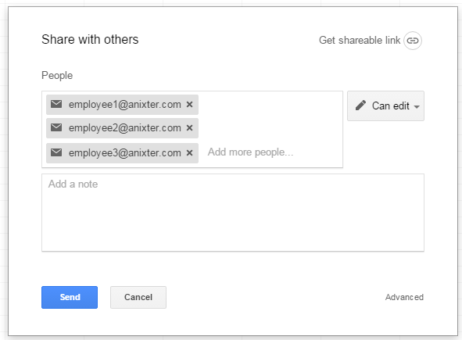

Part B Complete
Part C: Upload a New Day’s Sheet (daily)
[C1]: Preserving the current sheet (saving)
- Go to File -> Download as -> Microsoft Excel (.xlsx)
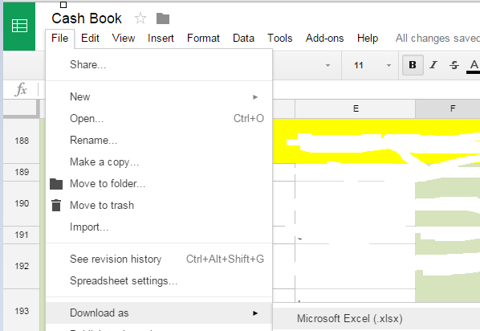

- If prompted for a location, save it in the proper folder under a proper name for the file, overwriting the old file. If you are not prompted to save to a location, skip to part 3. This example saves the September Cash book:
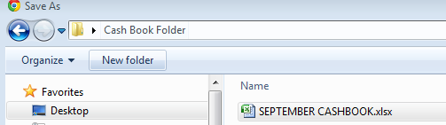

- Do this step if you were not prompted on where to save. Click the file that was downloaded. This should open the excel file.
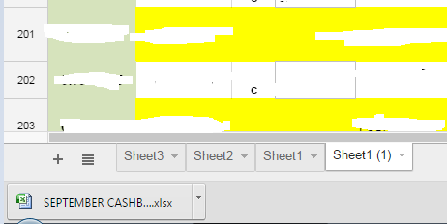
- Click File –> Save As and save it in the proper folder under a proper name for the file.
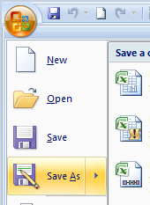
[C2]: Importing a new sheet (uploading)
- Go to File -> Import…
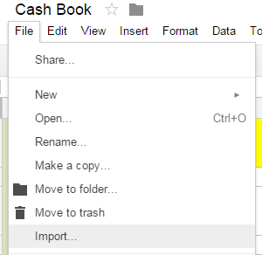

- Click Upload, and click “Select a file from your computer”
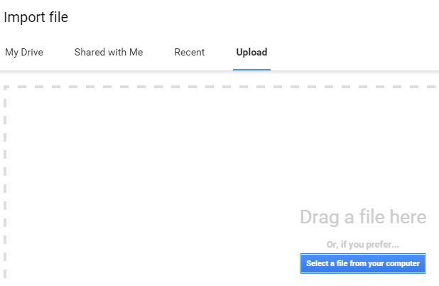
- Navigate to the folder with the file you want uploaded, select, and click open.
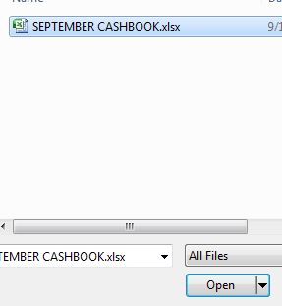

- Click Replace spreadsheet, and click Import
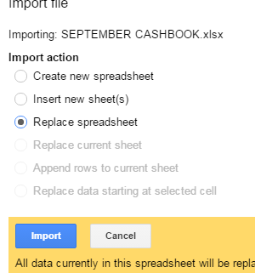

Part C Complete

